SECTION 4.55 (2) MODIFICATION

DA & Property: | DA2015/177/2  40-42 Madeline Street Strathfield South- LOT 24 DP 1200563
Proposal: | S4.55(2) Modification Application for alterations and additions to an approved materials recycling facility.
Applicant: | J Cosgrove
Owner: | LC Investment (Australia) Pty Ltd
Date of lodgement: | 19 November 2021
Notification period: | 24 November – 14 December 2021
Submissions received: | 3
Assessment officer: | J Gillies
Estimated cost of works: | $16,850,000.00
Zoning: | IN1-General Industrial - SLEP 2012
Heritage: | No
Flood affected: | Yes
Is a Clause 4.6 Variation Proposed: | No
RECOMMENDATION OF OFFICER: | REFUSAL

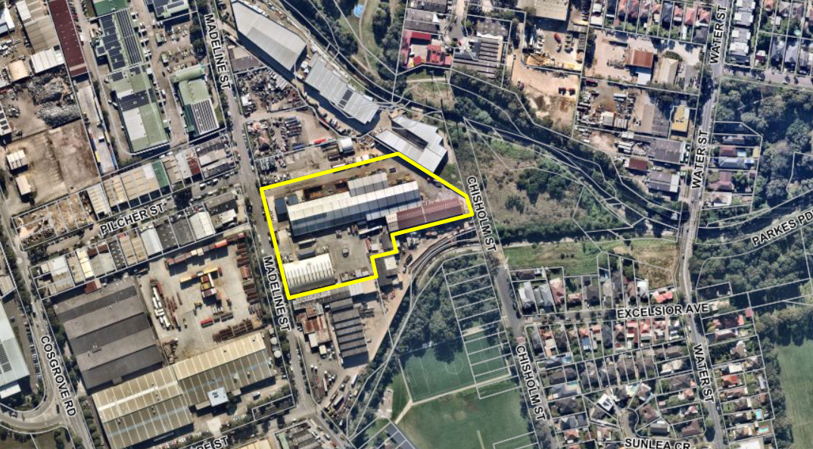
Figure 1 – Locality Plan

EXECUTIVE SUMMARY

Proposal

Approval is being sought for the modification of DA 2015/177 to permit alterations and additions to an approved materials recycling facility. The Sydney East Planning Panel (then the JRPP) approved DA 2015/177 in October 2016 permitting use of the site as a waste management facility with an annual capacity of 30,000 tonnes of paper and cardboard and 69,900 tonnes of mixed metals, glass and mixed plastic.

Site and Locality

The site is identified as 40-42 Madeline Street, Strathfield South and has a legal description of Lot: 24 DP: 1200563. The site is an irregular shaped parcel of land with a total area of 18,971m² and is located on the eastern side of Madeline Street. The site is bound by other industrial uses to the north and south and to the east adjoins a grassy reserve with various owners.

Environmental Planning Instruments

The site is zoned IN1 General Industrial pursuant to the Strathfield Local Environmental
Plan (SLEP), 2012. The zoning provisions of the SLEP prohibit the use of the site as a
waste transfer station however the use is made permissible under Division 23 of the Transport and Infrastructure SEPP. The proposed modification is consistent with the requirements of the Transport and Infrastructure SEPP, however is inconsistent with requirements under the Resilience and Hazards SEPP.

Development Control Plan

The proposed development as amended is inconsistent with a number of requirements under Part D and Part H of Strathfield Consolidated Development Control Plan 2005.

Notification

The application was notified in accordance with Council’s Community Participation Plan from 24/11/21 – 14/12/22, where 3 submissions were received raising the following concerns;
- The current operation does not abide by the conditions imposed under the original / current consent,
- Moving MRF processing to Building 2 will exacerbate noise impacts for residents situated in dwellings south east of the site (on Chisholm St and Excelsior Ave), and
- Lack of fire plan.

Issues

- Acoustic attenuation and proposed amendments to Condition 76,
- Acoustic modelling and re-location of MRF processing to Building 2, and
- External (outside of enclosed warehouses) storage of baled and sorted waste.

Conclusion

Having regards to the heads of consideration under Section 4.15 of the Environmental Planning & Assessment Act 1979, Development Application 2015/177/2 is recommended for
refusal subject to the attached reason of refusal.

REPORT IN FULL

Proposal

Approval is being sought for the modification of DA 2015/177 to permit alterations and additions to an approved materials recycling facility. The Application does not seek approval for changes to the approved processing capacity at the site, the submitted Statement of Environmental Effects (SEE) referring to increased operational efficiency as the objective of the proposed modifications.

The proposed modifications are as follows:

- Amend Condition 1 (Plans) to approve the following alterations and additions:
  - Relocation of Materials Recycling Facility (MRF) and Paper and Cardboard Recycling (PCR) infrastructure. Building 2 is proposed to house MRF equipment and Building 3 is proposed to house PCR equipment for baling and storage of cardboard.
  - Revisions to the parking layout (with no change in the total number of parking spaces, being 29),
  - Relocation of a substation to the front of the property,
  - Two extensions to Building 1,
  - An extension to Building 2,
  - Glass (processed) storage bunkers located on the northern side of Building 1,

- Amend Condition 38 (Material Storage) to permit the external storage of baled and sorted waste.
- Amend Condition 45 (Use of Building 3) to permit baling and storage of paper and cardboard.
- Amend Condition 76 (Noise Limits) to reference the Project Specific Noise Criteria (PSNC) established in the approved acoustic report prepared by SLR.

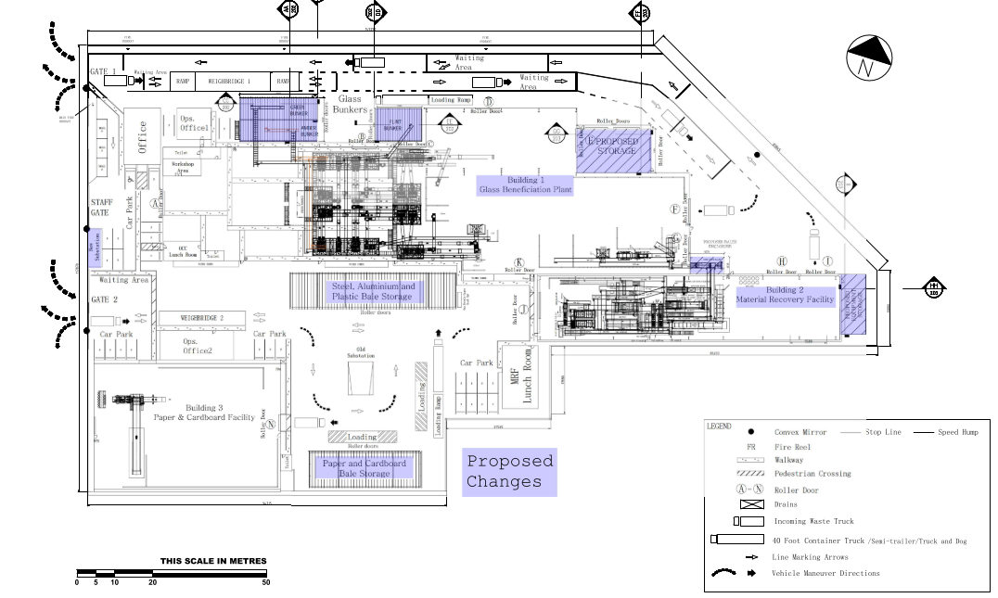Figure 2 – Proposed Site Plan

The Site and Locality

The site is identified as 40-42 Madeline Street, Strathfield South and has a legal description of Lot: 24 DP: 1200563. The site is an irregular shaped parcel of land with a total area of 18,971m² and is located on the eastern side of Madeline Street. The site is bound by other industrial uses to the north and south and to the east adjoins a grassy reserve with various owners.

The subject site is located at the south-eastern tip of a large industrial precinct spanning the suburbs of Greenacre and Strathfield South which extends from Liverpool Road in the north and runs either side of the Enfield Intermodal and rail line. This places the site near to the adjoining land use of the industrial area, which is low density residential development in the suburb of Belfield. Cox’s Creek, which feeds the Cooks River, and a number of parks and reserves are located between the site and adjoining residential areas.

The site currently comprises three principal buildings, with a number of smaller ancillary structures including weigh bridges, offices, a power substation and material storage areas. The Main building is a brick building with timber and corrugated iron extensions, referred to as Building 1. Building 1 has extensions on the northern side where offices are located.

Building 2 is located in the south-eastern corner of the site and sides onto Building 1 and is constructed of corrugated iron sheets. Building 3 is located in the south western corner of the site, with a similar construction to Building 2. An office is attached to Building 3 which adjoins one of the weigh bridges.

The site is orientated towards Madeline Street and has three entry points. The northern and southern entry gate lead to weigh bridges, with the middle entry gate leading to a staff parking area. Staff parking is located at the front of the site and along the southern edge of Building 1.

Operation

The site is currently operating as a waste transfer station, with DA2015/177 permiting the processing of 99,900 tonnes of materials annually (tpa). Of the 99,900 tpa of material processed at the site, up to 69,900 tpa is processed by the Materials Recovery Facility.

Of the 99,900 tpa capacity, the site is approved to accept up to 30,000 tpa of source separated paper and cardboard material for processing by the Paper Cardboard Recycling facility.

Figure 3 below shows the approved site layout. As noted in the image, the following uses exist across the site:

- MRF within building 1,
- PCF within Building 2,
- No approved uses within Building 3,
- External storage bunkers,
- Weigh bridges,
- Ancillary offices,
- 29 parking spaces, and
- On-site substation.

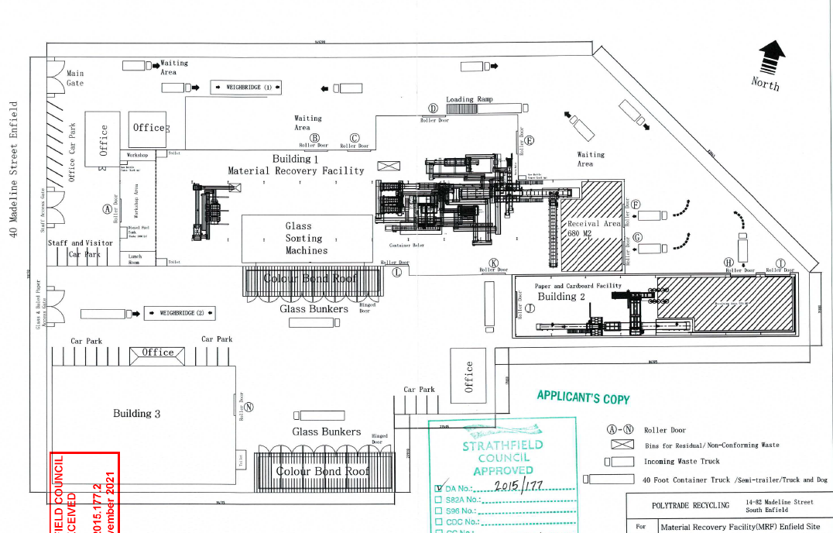
Figure 3 – Approved site layout (DA2015/177)

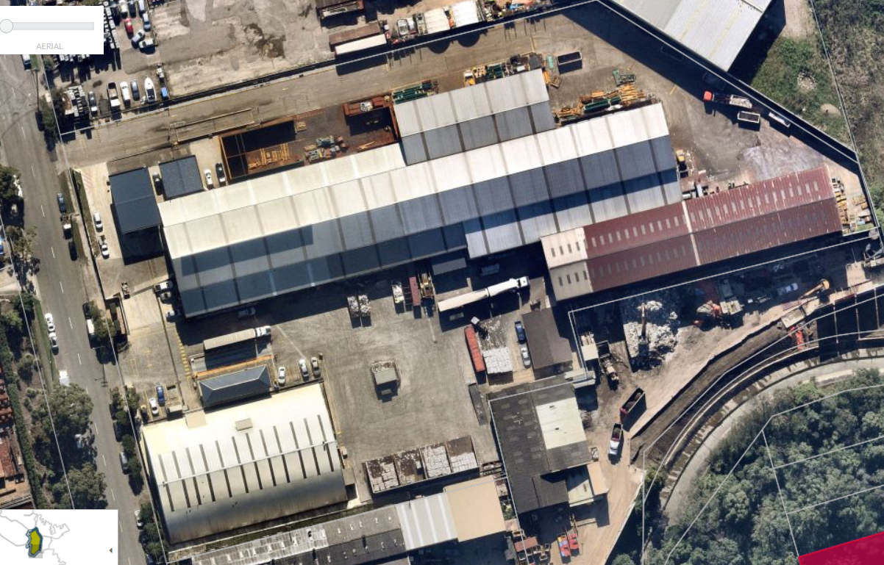
Building 3
Building 2
Building 1
Figure 4 – Aerial close up of the site.

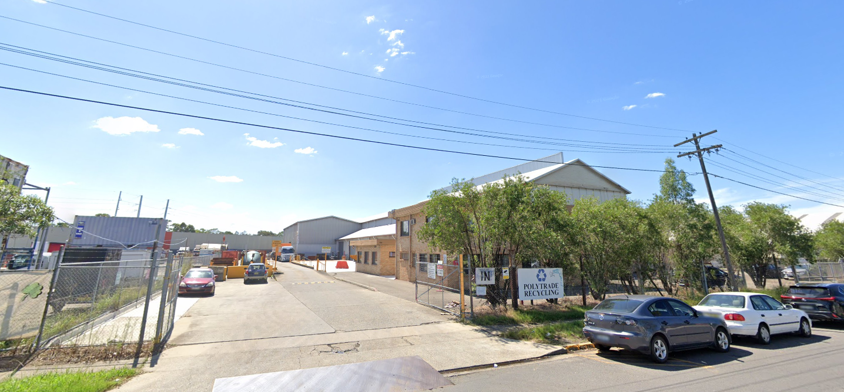
Figure 5 – Northern entry/driveway to the site from Madeline Street

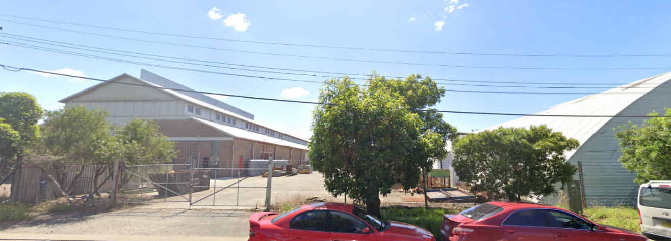
Figure 6 – Southern entry/driveway to the site from Madeline Street

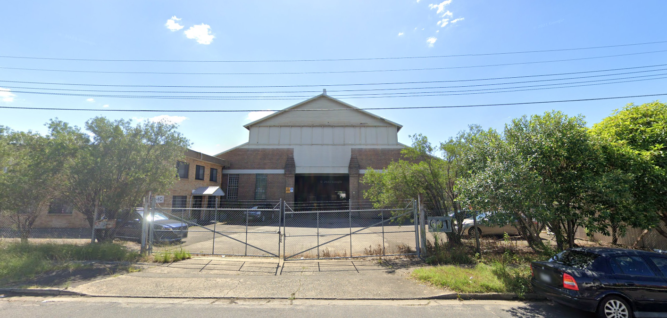
Figure 7 – Middle entry/driveway to the site from Madeline Street

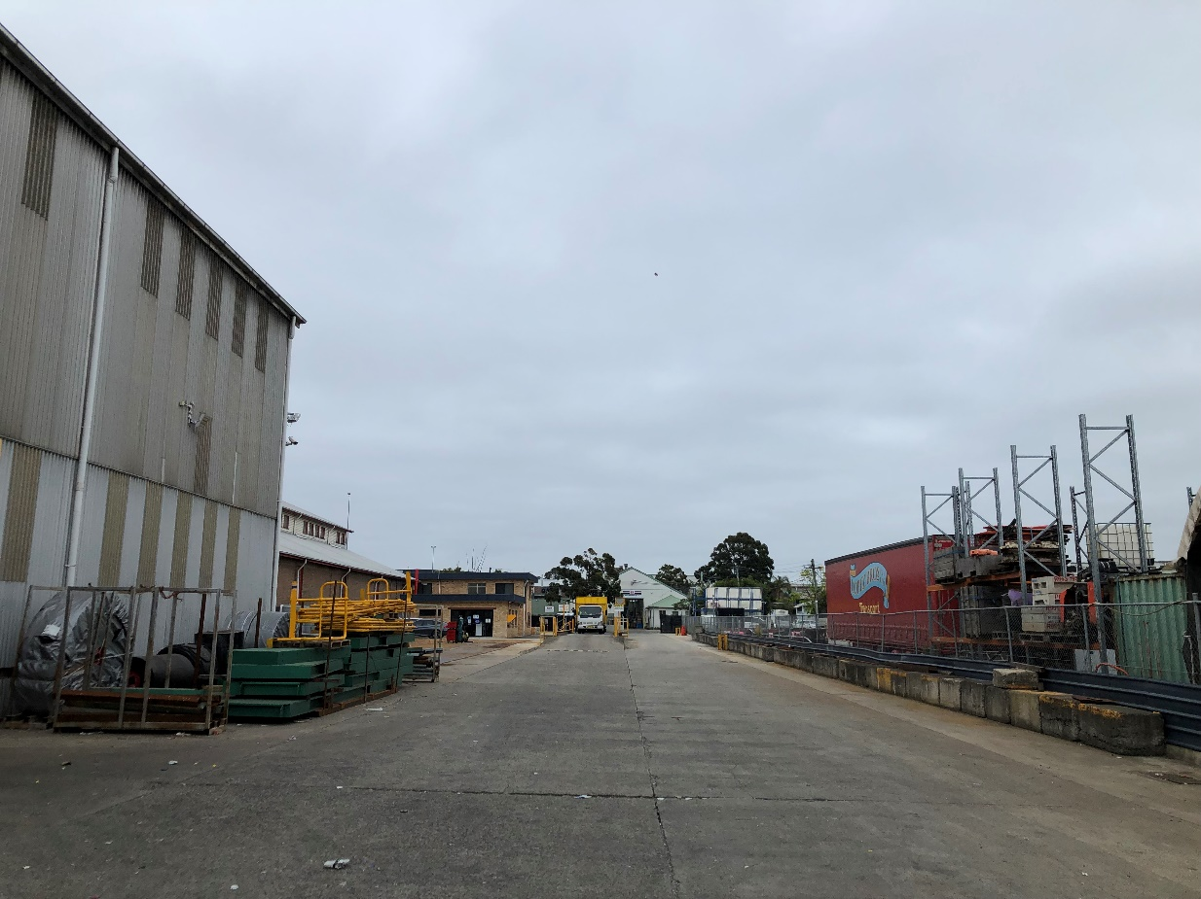
Figure 8 – Looking towards Madeline Street across the weighbridge near the
northern boundary with Building 1 on the left side of the photo

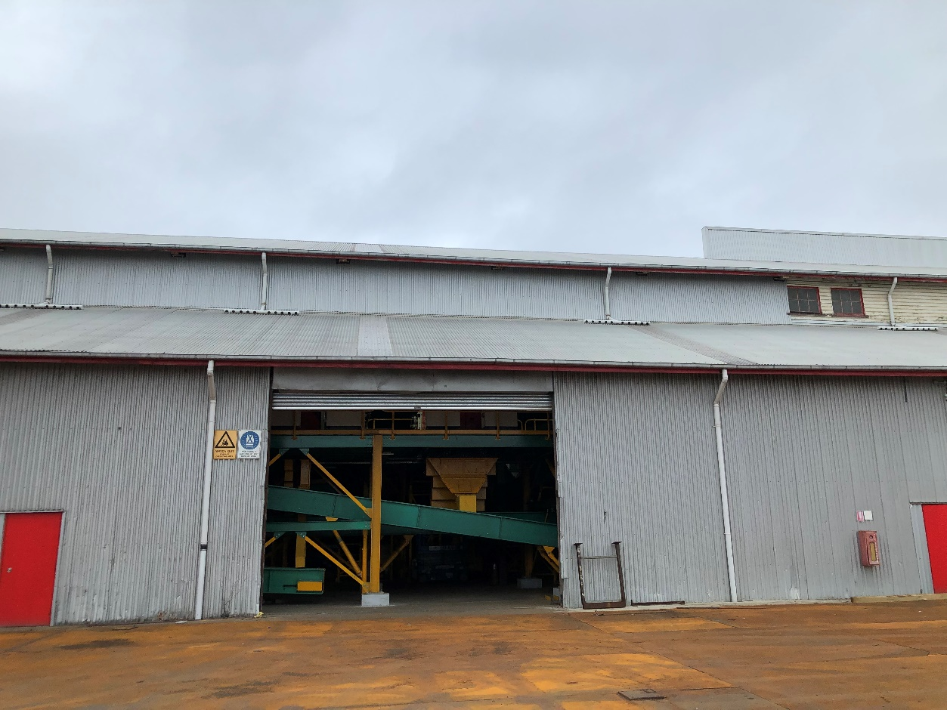
Figure 9 – The norther elevation of Building 1 with sorting machinery inside

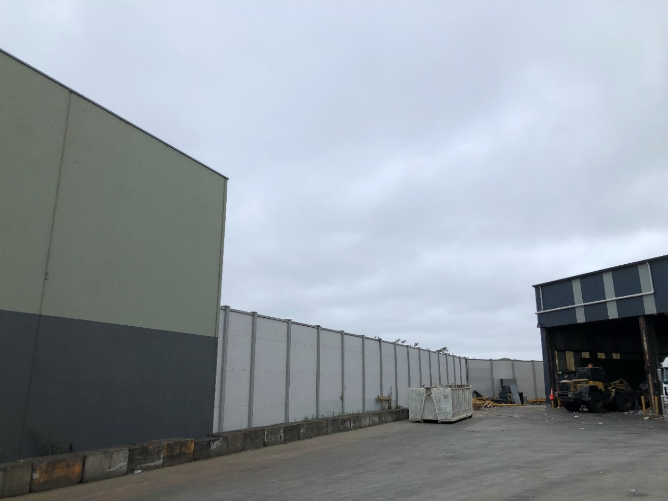
Figure 10 – north eastern boundary of the site showing the acoustic wall and rear of
Building 2

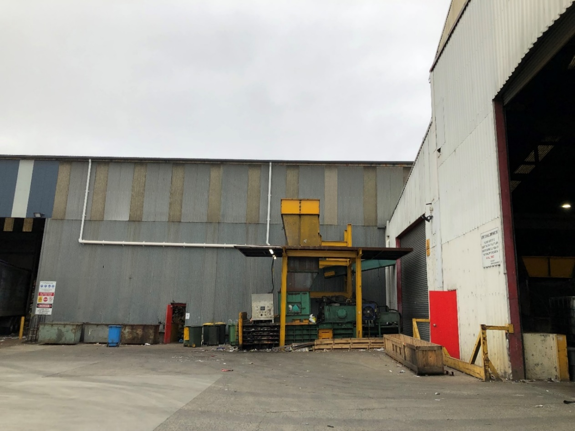
Figure 11 – Rear of Building 1 where it adjoins Building two on the northern side

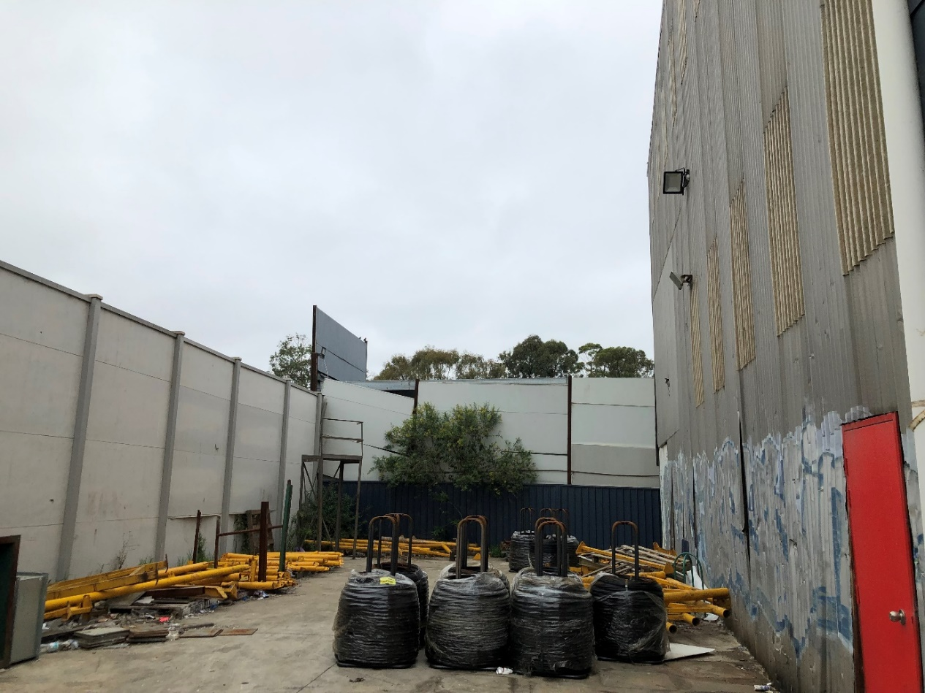
Figure 12 – Rear of Building 2. The photo is taken looking south at the boundary with
Aussie Skips being another industrial use which adjoins Cox’s Creek, with Cooke Park
and the streets of Belfield located to the south of this

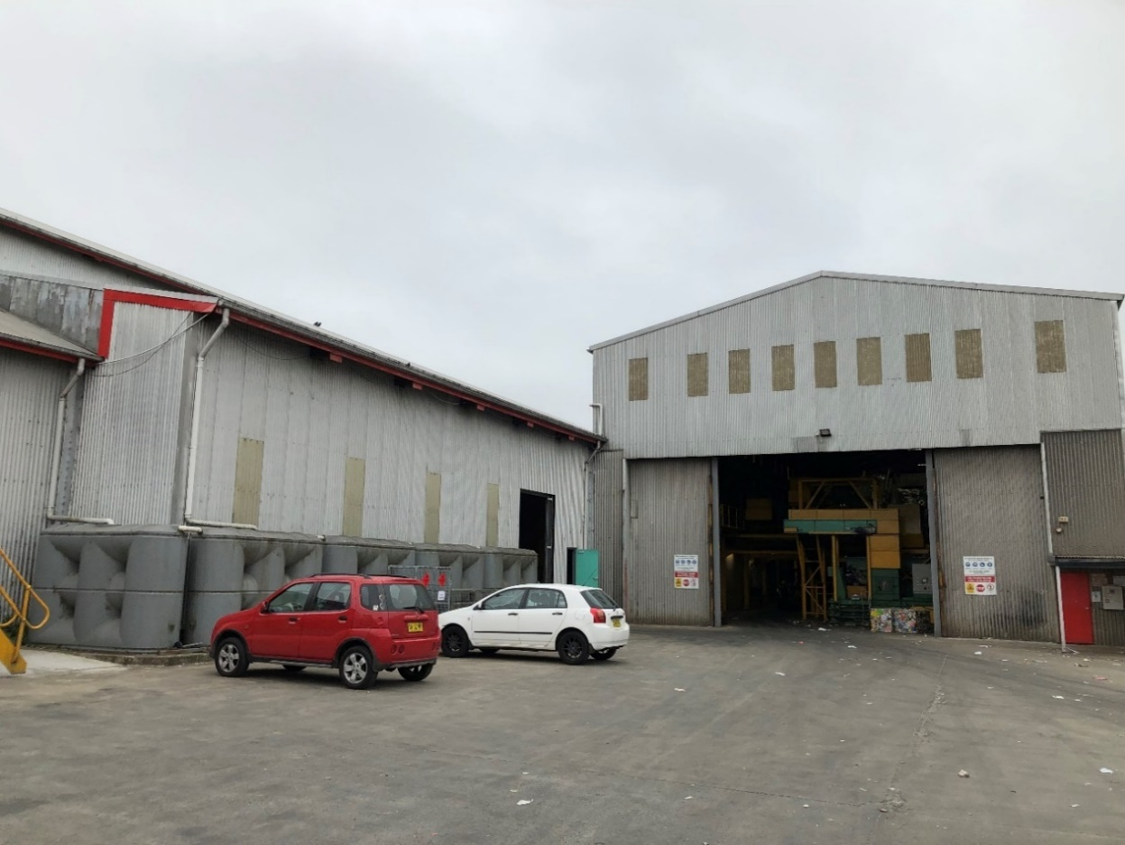
Figure 13 – The front of Building 2 where it adjoins Building 1 on the southern side

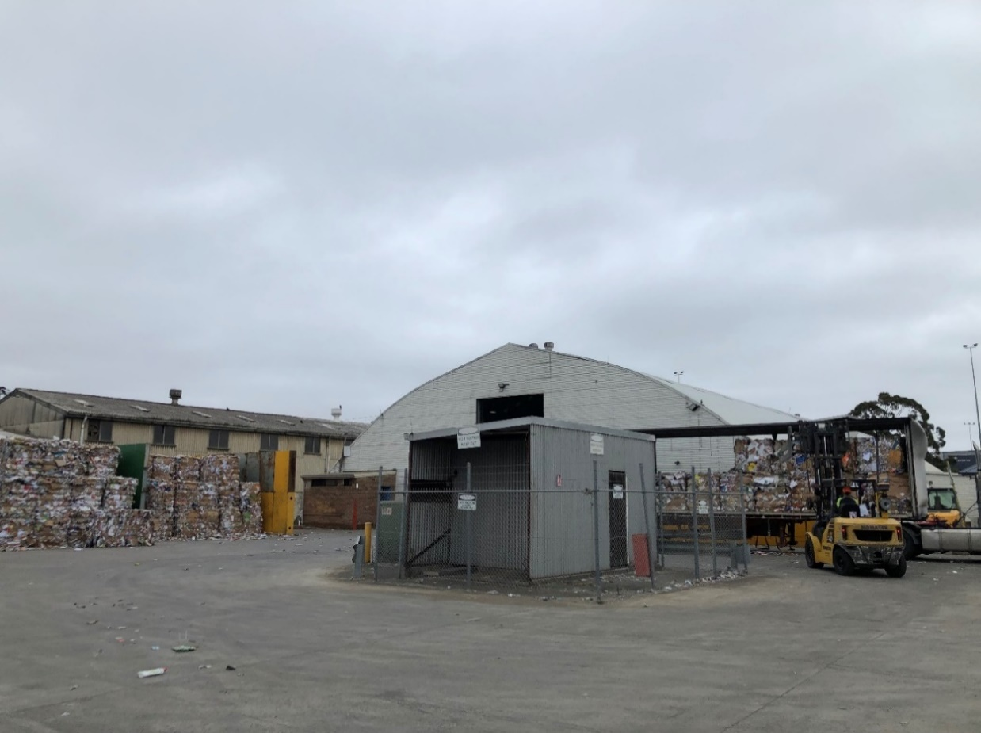
Figure 14 – The existing substation, with baled paper and cupboard on the left and
the rear of Building 3 in the background

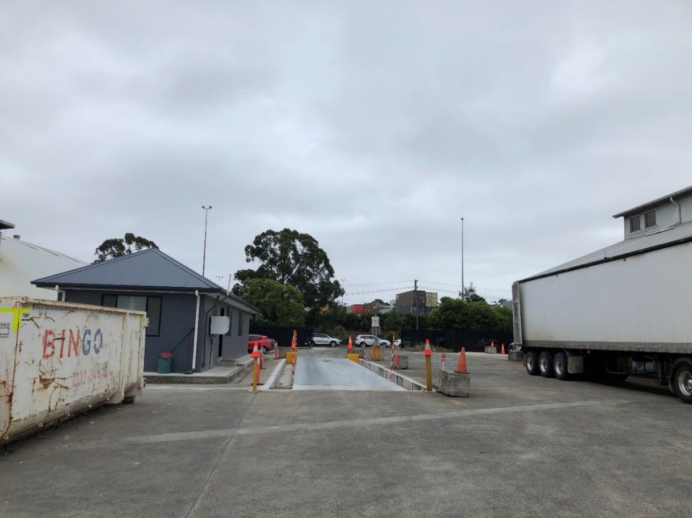
Figure 15 – The weighbridge leading to the southern entry from Madeline Street
with office structure adjoining Building 3 on the left of the photo

Background

16 April 1993 Strathfield Council issue consent for operation of a paper and cardboard recycling facility (DA93/01) and subsequently the EPA issue license no. 20576.

26 October 2016 The Sydney East Joint Regional Planning Panel approved DA2015/177 permitting use of the site as a waste management facility with an annual processing capacity of 30,000 tonnes of paper and cardboard and 69,900 tonnes of mixed metals, glass and mixed plastic. Subsequently, the EPA issue EPL number 20576.

19 November 2021 The subject Modification Application is lodged with Council.

24 November 2021 The subject modification was neighbour notified for a period of 14 days in accordance with Council’s Community Participation Plan (CPP). Three (3) submissions were received during and immediately following this period.

8 December 2021 Council’s Planning Officer and Environmental Health Officer undertake a site inspection guided by members of the Polytrade (current operators) team.

Referrals - External

Environment Protection Authority (EPA)

The approved development under DA2015/177 is subject to an operating Environment Protection License which was required following assessment of the application as designated development. Accordingly, the subject modification was referred to the Environment Protection Authority (EPA). The Resilience and Hazards SEPP (2021) also requires referral to the EPA. Referral comments are provided below (refer to GTA for full letter):

I refer to the development application and accompanying information provided for the above modification application received by the Environment Protection Authority (EPA) on 6 December 2021. EPA has reviewed the information provided and has determined that it is able to issue General Terms of Approval (GTAs).

If the development is modified either by the applicant prior to the granting of the consent, or as a result of conditions imposed by Council, we request that further consultation occur with us about the proposed changes prior to the consent being issued. This will enable us to determine whether our GTA are required to be modified as a result of any proposed alterations.

Polytrade operates at 40 Madeline Street, Strathfield South and are above the Protection of the Environment Operations (POEO) Act 1997, Schedule 1 threshold for resource recovery and waste storage activities.

Therefore the company requires, and holds, an Environment Protection Licence (EPL number 20576) to undertake these activities issued by the EPA under the POEO Act.

Noise related issues

In assessing the proposal, the EPA has identified issues related to noise that Strathfield Council may wish to consider in its overall assessment of the application, as mentioned below.

Applicable Noise Criteria

Section 1.1 of the Statement of Environment Effects (SEE) states that it is also proposed to modify a number of conditions in the existing development consent, specifically (in relation to noise) Condition 76, which sets noise limits for
the premises (SEE Table 2). These noise limits are also reflected in Condition L3.1 of the EPA General Terms of Approval in the D&SR, and the Environment Protection Licence for the premises (EPL 20576).

The SEE states that this condition ‘incorrectly lists the noise level predictions from the Noise Report completed by SLR in 2015, not the Project Specific Noise Criteria’.

The EPA notes that any noise assessment supporting the initial development application in 2015 would have been carried out in accordance with the NSW Industrial Noise Policy (INP) which was current at that time. Hence, the derivation of
noise limits for an approval were correctly carried out in accordance with INP Application note 'Determining noise limits for licence conditions', which states:

‘Where the proponent predicts that noise levels from the industrial development would be below the project-specific noise levels, then the noise limits specified in the licence/consent conditions should reflect the noise levels that the proponent
states would be achieved (that is, the predicted noise levels, however a minimum intrusive criterion of 35 dB(A) still applies).

This is to:
- ensure that the proponent adopts best-management practices and best available technology described in the noise impact assessment report ensure that the level of achievable performance presented by the proponent to the public though public documentation such as Environmental Impact Statements, is achieved
- optimise the opportunity for further industrial development in the area without an unacceptable degradation of the acoustic amenity of the area
- fulfil a general aim of the environmental assessment process to minimise environmental impacts’

For this proposed Modification, a brief outline of potential noise impacts has been provided in Section 5.4 of the SEE. Section 5.4.2 states that operational noise impacts from the premises are not expected to change as only minor layout
changes are proposed. As no substantial changes are proposed, and no new noise impact assessment has been prepared to support the application, the EPA recommends that the current development consent criteria, based on the
predicted noise levels in the original development application, should continue to apply to the Modification, if approved.
If the proponent considers that the proposed Modification cannot achieve the current development consent noise limits, then a new noise impact assessment should be provided for the premises to support the proposal.

Construction Noise Assessment

Section 5.4.2 of the SEE states that construction activities with a potential duration of 2-4 weeks will be required to complete the proposed alterations to the site layout. No information is provided in the SEE on the types, quantities and noise emissions of the plant and equipment to be used during construction.

While activities are only proposed to be carried out during the recommended standard hours in Section 2.2 of the Interim Construction Noise Guideline (ICNG), to understand potential impacts from construction activities, a quantitative
assessment of construction noise impacts should be included in the SEE as they pertain to commercial development with the potential to affect a sensitive land use for more than three weeks in total. All feasible and reasonable noise mitigation and management measures should be implemented to address any noise impacts and minimise construction noise levels at sensitive receivers.

With regard to the ‘Applicable Noise Criteria’ comments provided by the EPA, the issues raised are expanded on in Internal Referrals below.

With regard to the EPA’s comments on construction noise, appropriate conditions of consent could be incorporated into an amended consent to address this.

Ausgrid

The Application was referred to Ausgrid under clause 45(2) of the State Environmental planning Policy (Infrastructure) 2007.

Ausgrid provided their consent to the proposed modification, subject to the inclusion of specific conditions in an amended consent.

Sydney Water Corporation

The Application was referred to Sydney Water noting the site’s proximity to the Cooks River and noting previous correspondence with Sydney Water on the parent Application. Sydney Water offered no objection to the proposed modification.

Referrals – Internal

Environmental Health

The Application was referred to Council’s Environmental Health Team who provided the following comments:

The application seeks to modify condition 76 of DA2015/177, contending it was an incorrect application of the Industrial Noise Policy for Industry, and to utilize Building 2 as a material recycling facility and building 3 for Paper & Cardboard Recycling.

The Waves Consultant Advice Notice Polytrade – Material Recovery Facility Noise Compliance Audit (29.10.2021) (“the Waves Report”) contends the noise levels contained within condition 76 were an incorrect application of the results of the noise reports submitted as part of the assessment. The Waves Report contends PSNC from Table 33 should apply instead of the lower dB as listed in the “calm” column of the Table

NSW General Terms of Approval Notice No: 1615791 advises the noise limits reflect a correct application of the NSW Industrial Noise Policy 2000, the relevant policy at the time. Specifically, the Application Notes require the noise limits to be set at any lower limit the proponent predicts can be met.

In this regard, the condition 76 is a correct application of the policies at the time. The applicant at the time demonstrated that lower levels could be met and these levels were applied in the development consent.

The applicant does not submit any new information that justifies modifying the noise limits. Likewise, the application does not present any evidence demonstrating the proposed changes will not be a source of offensive noise to the surrounding neighbourhood.

In fact, the Waves Consultant Advice Notice Polytrade – Material Recovery Facility Noise Compliance Audit (29.10.2021) demonstrates via its monitoring that current operations fail to comply with requirements.

I cannot recommend approval for the following reasons:
- The site has a history of breaching hours of operation, causing offensive noise to the surrounding residents.
- The site is subject to ongoing noise complaints from surrounding residents.
- The application fails to demonstrate the EPA incorrectly applied the Industrial Noise Policy at the time the original consent was issued, and as such condition 76 should not be modified.
- The NSW EPA recommend no changes to condition 76.
- The premises has not submitted any evidence or report demonstrating the proposed changes will not cause offensive noise. The only evidence submitted suggests the premises fails to comply with current conditions of consent.

I recommend the application to modify condition 76 and to utilize Building 2 as a material recycling facility and building 3 for Paper & Cardboard Recycling be refused.

Council’s manager of Compliance and Regulatory Services also outlined that the business has been the source of numerous noise complaints and that there a verified breaches of the existing approval including operating out of hours and working in sheds with roller doors open.

In regards to reason 5 above, it was clarified with Council’s referral officer that the proposed changes to Condition 1 (approved site layout) that would permit new locations for MRF as well as a number of other extensions and additions cannot be supported as the acoustic report submitted does not establish acoustic attenuation measures for the proposed changes.

Without an acoustic report that addresses the proposed layout and operational changes, Council would not be unable to amend conditions to incorporate a requirement for verification of noise compliance at a later date through noise monitoring and a verification report. Further and as noted above, the acoustic report that has been submitted, demonstrates non-compliance with the existing noise limits under Condition 76, which the EPA has advised should be retained.

EP&A Regulation 2000 – Designated Development

The site has previously been approved (DA2015/177) to operate as a ‘Resource Recovery Facility’ pursuant to Schedule 3 of the EP&A Regulation 2021, under the designated development planning pathway. Schedule 3, Part 2 of the Regulation indicates that development involving alterations or additions is not designated if there is no significant increase in the overall impact of the development compared to the approved development.

As the approved development under DA 2015/177 is subject to an operating Environment Protection License, the proposal is to be referred to the Environment Protection Authority (EPA), with comments noted above.

The proposed modifications to the physical layout, including location of MRF within Building 2 and PCF in Building 3 are unlikely to result in a significant increase in the overall impact of the development. Council has raised concern with the ability to apply new acoustic attenuation measures if necessary and concerns with amending the noise limits (Condition 76), however both matters relate to properly and accurately managing the existing operation, which would remain unchanged in terms of tonnage and general management under the proposed modification.

In addition to noise impact assessments, the original development was supported by the following information which has been commented on below in the context of the proposed modification.

- Traffic and Parking Impact Assessment – The modification does not increase the capacity of the site or seek to increase truck movements or parking spaces.
- Air Quality Impact Assessment – The modification will not significantly change the existing operation which has been assessed as suitable in terms of air quality impacts,
- Soil and Water Assessment - The modification will not impact on the assessment of these impacts under DA2015/177.
- Seven Part Test and Threatened Species Impact Assessment - The modification will not impact on the assessment of these impacts under DA2015/177.
- Visual Impact Assessment – The proposed modification incorporates some minor new structures as additions to existing warehouses, however these additions are all well below the roof line of existing structures at the site.
- Waste Management Measures - The modification will not impact on the assessment of these impacts under DA2015/177.

As such, the proposed modification is not a significant increase in the overall impact and is not designated.

Section 4.55 of the EP&A Act 1979

The Application has been lodged under the provisions of Section 4.55(2) of the EPA Act. The application is not considered to be of minimal environmental impact, however it is considered to be substantially the same development for which consent was originally granted. The Application incorporates a number of alterations and additions to existing buildings, relocation of existing processing infrastructure across the various buildings, rationalising of ancillary structures and parking and proposed amendments to a number of conditions, most notably in relation to noise emission control.

Noting the scope of the proposed changes, the Application will not result in a change to the quantity of waste processed at the site and there are no proposed changes to the approved number of trucks entering or existing the site. Accordingly, the proposed ‘rationalisation’ of the site’s operation would not result in significant changes to the management, collection and transport of waste products at the site and the modified development would be substantially the same development as approved.

Also in accordance with the provisions of Section 4.55(2), the Application has been notified in accordance with the provisions of Council’s CPP and any submissions made will be considered as part of this assessment. In addition, under the provisions of s4.55 (3), the reasons for the granting on the consent that sought to be modified will be taken into consideration during the detailed assessment of the application.

Section 4.15 Assessment – EP&A Act 1979

The following is an assessment of the application with regard to Section 4.15 (1) of the Environmental Planning and Assessment Act 1979.

(1) Matters for consideration – general

In determining an application, a consent authority is to take into consideration such of the following matters as are of relevance to the development the subject of the development application:

- the provision of:
(i) any environmental planning instrument,
State Environmental Planning Policies
Compliance with the relevant state environmental planning policies is detailed below:

STATE ENVIRONMENTAL PLANNING POLICY (RESILIENCE AND HAZARDS) 2021

The Resilience and Hazards SEPP applies to the proposed development as the development is defined as an offensive industry as per the below definition:

offensive industry means a development for the purposes of an industry which, when the development is in operation and when all measures proposed to reduce or minimise its impact on the locality have been employed (including, for example, measures to isolate the development from existing or likely future development on other land in the locality), would emit a polluting discharge (including, for example, noise) in a manner which would have a significant adverse impact in the locality or on the existing or likely future development on other land in the locality.

Section 3.12 of Part 3 of the SEPP requires a consent authority to consider the following for potentially hazardous or potentially offensive development:

(a) current circulars or guidelines published by the Department of Planning relating to hazardous or offensive development, and
(b) whether any public authority should be consulted concerning any environmental and land use safety requirements with which the development should comply, and
(c) in the case of development for the purpose of a potentially hazardous industry—a preliminary hazard analysis prepared by or on behalf of the applicant, and
(d) any feasible alternatives to the carrying out of the development and the reasons for choosing the development the subject of the application (including any feasible alternatives for the location of the development and the reasons for choosing the location the subject of the application), and
(e) any likely future use of the land surrounding the development.

The parent application (DA 2015/177) was supported by a Hazard and Risk Assessment (screening test) in order to determine whether a Preliminary Hazard Analysis (PHA) of the proposal would be required. Council’s assessment confirmed a PHA would not be required and conditions of consent would allow for ongoing monitoring of potentially hazardous substances at the site.

As part of the parent application assessment, the Applicant prepared a ‘Plan for the Management of Non-conforming Waste’ detailing storage locations, methods, frequency and method of collection for materials which are unable to be processed by the site and which may enter the site comingled with deliveries of recyclable material. The approved Waste
Management Plan considers both hazardous non-conforming waste and residual waste
(garbage) and provides management methods supported by Council.

The proposed modification will not result in any significant change to the operation of the site in terms of non-conforming waste or any impact that would trigger the need for a PHA.

Noise Impacts

The parent application also incorporated a detailed assessment of noise impacts, and the following is noted:

- The operation results in noise emissions that required assessment by an acoustic expert. This is primarily due to the location of sensitive receivers in close proximity of the site (residential areas to the south east an east),
- The Applicant provided an acoustic assessment (prepared by SLR Consultants) that established project specific noise criteria (PSNC),
- Council had the Applicant’s acoustic assessment peer reviewed by an external consultant employed by Council (Acoustic Dynamics). Council’s consultant confirmed that in general the modelling and data submitted by SLR was sound, however Council’s consultant set slightly more conservative PSNC. It is understood that due to the minor variation in PSNC, the Applicants reporting (by SLR) was ultimately supported.
- The EPA provided, in their General Terms of Approval, noise limits that were more conservative than the PSNC provided by SLR and Acoustic Dynamics.

The outcome of the above acoustic investigation and advice was the inclusion of the following conditions in the NOD for DA2015/177:

- Condition 1 – which includes the reports prepared by SLR as stamped / approved.
- Condition 9 which requires an acoustic auditing program upon commencement of the proposed use (once at 40 days, once at 6 months and once at 10 months). It is noted that evidence of the completed auditing could not be located on Council’s data base and the Applicant has not provided it with the Application, however it was not specifically requested during the assessment. It is also noted that this condition references PSNC established by SLR in their approved acoustic assessments.
- Condition 13 which required the construction certificate drawings to include a 4.5m high acoustic barrier along the full extent of the eastern and north-eastern boundaries of the site.
- Condition 76 which establishes the noise limits set by the EPA.
- Conditions 77 – 82 that establish the criteria for measuring compliance with the noise levels established in Condition 76.

It is noted that Condition 9 requires auditing to be undertaken in accordance with the SLR criteria (PSNC) established in the approved acoustic assessments and that Condition 9 does not directly reference the noise limits established by the EPA. This reflects some inconsistencies in the conditions applied with regard to acoustic attenuation and monitoring of the approved use.

The Applicant has proposed that it is the PSNC that should also be applied to Condition 76, rather than the EPA’s noise limits.

However, the EPA (consulted as a relevant public authority) have provided direct advice to Council that the noise limits established in Condition 76 have been based on the NSW Industrial Noise Policy and Council agrees with the NSW EPA statements on the following:

- The Applicant has outlined the modifications are minor and will not increase noise generation. Considering this, there should be no need to adjust the noise limits established in Condition 76.
- If the Applicant believes the modifications would result in increased noise generation, an amended acoustic assessment would be required to establish new attenuation measures for the predicted increases in noise.

Noting the EPA’s advice, Council is not in a position to amend Condition 76 to adopt the PSNC provided by SLR.

As the acoustic assessment submitted is only an assessment of current noise generated at the site against the PSNC and not an assessment of the modified layout, Council is not in a position to review Condition 76 which would need to be supported by amendments to other conditions to allow for any new attenuation requirements and auditing of noise generation following operation, whether that would be against the existing noise limits in Condition 76, or new noise limits justified by the Applicant and their acoustic consultant.

Further, and as noted in Council’s Environmental Health referral, the acoustic audit submitted by the Application with the subject modification demonstrates that currently the site is not meeting the noise limits established in Condition 76.

Chapter 4 – Remediation of Land

Chapter 4 of the SEPP covers the planning approach for the remediation of contaminated land.

Assessment of the parent Application has considered the likelihood of the site being contaminated, noting that the former site comprised existing hardstand areas and Council’s records did not identify the site as containing known contaminates. It was concluded that a Phase 1 investigation of the site would not be required.

The proposed modifications will not result in any significant changes to the approved outcome and the conclusions in the assessment of the parent application area maintained.

The objectives outlined within SEPP are considered to be satisfied.

STATE ENVIRONMENTAL PLANNING POLICY (TRANSPORT AND INFRASTRUCTURE) 2021
Division 23 of the SEPP relates to waste or resource management facilities.

The subject site is zoned IN1 – General Industrial which is classified as a prescribed
zone under Section 2.152 of Division 23 of the SEPP. The SEPP prevails over the zoning provisions of the Strathfield LEP 2012 to permit the use of the site as a waste transfer station.

The SEPP defines a ‘waste transfer station’ as follows (standard instrument LEP definition):

a building or place used for the collection and transfer of waste material or resources, including the receipt, sorting, compacting, temporary storage and distribution of waste or resources and the loading or unloading of waste or resources onto or from road or rail transport.

As the proposed use of the site is consistent with this definition and is located within a
prescribed zone, the proposal is permissible with consent.

Traffic Generating Development

In accordance with the requirements of Section 2.122 Traffic-generating development under Division 17 Roads and Traffic of the SEPP, the parent application was referred to the NSW RMS.

The proposed modification will not result in increased parking spaces or truck movements as no changes are proposed to the capacity of the site’s throughput of waste. Accordingly, the existing GTA’s remain relevant and the proposed modification was not re-referred to the RMS as traffic generating development.

Strathfield Local Environmental Plan

The site is zoned IN1 General Industrial pursuant to the Strathfield Local Environmental
Plan (SLEP), 2012. The zoning provisions of the SLEP prohibit the use of the site as a
waste transfer station, however the use is made permissible under Division 23 of the Transport and Infrastructure SEPP.

Part 4 – Principal Development Standards

The proposed modification incorporates a number of small extensions and ancillary structures (new glass bunkers) that will increase the gross floor area across the site. Notwithstanding, the site will remain compliant with the 1:1 FSR standard pertaining to the site.

The new structures all below the 12m height of building limit applying to the site.

Part 5 – Miscellaneous Provisions

Flood Planning

The subject site has been identified as being at or below the flood planning level. The application as modified has been reviewed by Council’s Engineer who has advised that subject to suitable conditions, the development is considered compatible with the flood hazard of the land, will not result in significant adverse effects on flood behaviour or environment and is not likely to result in unsustainable social and economic loss. The proposed development is considered to satisfy the objectives of this clause.

Part 6 – Additional Local Provisions

Acid Sulfate Soils

The subject site is identified as having Class 5 and Class 4 Acid Sulfate Soils. As the original development did not involve any significant excavation works, an Acid Sulfate Soils Management Plan was not required in accordance with SLEP 2012.

The proposed modification does not incorporate any significant excavation works for the new structures. Accordingly, an Acid Sulfate Soils Management Plan is not required.

Earthworks

The proposed modifications do not include any significant excavation works. Any excavation for footings or levelling of the site is considered to be minor and will not have a detrimental impact on environmental functions and processes, neighbouring uses, cultural or heritage items or features of the surrounding land.

Essential Services

Clause 6.4 of the SLEP 2012 requires consideration to be given to the adequacy of essential services available to the subject site. The subject site is located within a well serviced area and features existing water and electricity connection and access to Council’s stormwater drainage system. As such, the subject site is considered to be adequately serviced for the purposes of the proposed development

It is considered that the proposed development satisfies the aims, objectives and development standards, where relevant, of the Strathfield LEP 2012.

(ii) any draft environmental planning instrument that is or has been placed on public exhibition and details of which have been notified to the consent authority, and

There are no draft planning instruments that are applicable to this site.

- any development control plan,

The proposed development, as modified is subject to the provisions of the Strathfield Consolidated Development Control Plan 2005. The following comments are made with respect to the proposal satisfying the objectives and controls contained within the DCP.

PART D – Industrial Development (SCDCP 2005)

Part D of Strathfield Consolidated Development Control Plan applies to the proposal and relevant sections are considered below.

Control | Comment
2.2 Contamination  Consideration as to whether the site is  potentially contaminated. | Refer to SEPP discussion above. Proposed modification is compliant with the development control.
2.4 Development Adjoining Residential Zones  - Noise to be insulated or minimised.  - Plant and equipment operating in ‘night  time’ hours to be subject to acoustic report.  - Shall not cause nuisance to residents by way of hours of operation, traffic,  parking, headlight glare, security lighting  and the like. | With regard to potential nuisances associated with traffic, hours of operation, lighting and parking, these have been considered in the assessment of DA2015/177 and the proposed modification will not result in changes that would trigger re-assessment.  With regard to noise the proposed modifications to Condition 76 cannot be supported as discussed elsewhere in this report (see Resilience and Hazards SEPP section).  Accordingly, insufficient information has been provided for consideration of Control 2.4 and the proposal is non-compliant with the development standard.
2.9 Parking Access and Manoeuvring  - Parking Rate controls  - Loading areas at rear  - Access to be via non-residential streets and to comply with relevant AS  - Vehicles to enter and exit in forward direction  - Entry and exit points and parking to allow for safe pedestrian access | The proposal incorporates some changes to the internal off-street parking arrangement, with the total number of parking spaces remaining the same at 29. It is noted that the proposal required a total of 35 parking spaces, however this was assessed as acceptable considering the type of industrial use and generic nature of Council’s Industrial land parking rates.  In the event of an approval, conditions of consent could be amended requiring parking spaces to comply with the relevant Australian standards.  In terms of pedestrian safety, it is noted that parking areas are generally adjacent to offices and lunch rooms, which is ideal.  All matters relating to traffic generation would be unchanged by the proposed modification as the proposal maintains the approved waste throughput and retains two weighbridges which were required to address potential truck queuing issues.
- Noise Pollution  - Buildings designed to minimise transmission of noise. | The proposal incorporates use of the existing structures for a re-location of MRF and PCF across the site and some small extensions and new glass bunkers. Although this is not expected to significantly increase the noise emissions from the site, with the overall operation generally remaining unchanged, an acoustic assessment that considers the amended layout has not been provided. As noted elsewhere in this report, this is required in the context of proposed amendments to Condition 76 and more generally required for Council to support a revised layout noting the site’s history of noise compliance.
2.14.3 Water Pollution  - Type/Volume and Storage of Chemicals  to be provided with DA.  - Only clean water discharged into stormwater system  - Internal floors graded/drained | The NOD for DA2015/177 incorporates conditions of consent that require suitable on-site stormwater management. These conditions would remain relevant under the proposed changes to the site layout and operation.

PART H – Waste Management (SCDCP 2005)

The Applicant has submitted a waste management for the construction of the proposed alterations and additions that meets the requirements of Part H in terms of construction.

In considering the overall aims and objectives of Part H and the specific requirements for Industrial Development, the Applicant has not provided adequate information to justify the changes to Condition 38 which prohibits the external storage of baled and sorted waste. Of note are the following components of the DCP:

- 1.6(c) To minimise the overall environmental impacts of waste and to provide advice to the community on how to prepare Waste Management Plans, detailing actions to minimise waste generation and disposal.

- 3.9.3(a) The WMP should be prepared in accordance with the template contained in Appendix A of this Plan.

- 3.9.3(c) - evidence of compliance or ability to meet compliance with specific industrial waste laws/protocols that apply due to the nature of activity undertaken or the type of waste produced (refer Clause 2.6 above)

It is understood that this condition was imposed to reduce the potential for loose materials leaving the premises and no supplementary mitigation measures have been submitted by the Applicant to justify removal of the condition.

It is also noted that during Council’s site inspection, external structures are currently being used for storage of baled and sorted waste (refer to Figure 14), which is a compliance mater with Condition 38. Further, on the approved site layout, these storage areas are identified as being rooved and are currently open, which is assumed to further undermine the management of waste at the site.

- Any matters prescribed by the regulations, that apply to the land to which the development application relates,

As outlined above, the site has previously been approved (DA2015/177) to operate as a ‘Resource Recovery Facility’ pursuant to Schedule 3 of the EP&A Regulation, under the designated development planning pathway. Schedule 3, Part 2 of the Regulation indicates that development involving alterations or additions is not designated if there is no significant increase in the overall impact of the development compared to the approved development.

The proposed modifications will not result in a significant increase in the overall impact of the development and is not designated.

- the likely impacts of that development, including environmental impacts on both the natural and built environments, and social and economic impacts in the locality,

Noise Impacts

A key modification proposed under the subject 4.55 Application is the amendment to Condition 76 (Noise Limits). The current noise limits reflect targets established by the EPA in their GTA’s for the original application (DA2015/177). These noise limits are as follows:

Location | Noise Limits dB(A)
 | Day  LAeq (15  minute) | Evening  LAeq  minute) | (15 | Night  LAeq minute) | (15 | Night  LA1 (1 minute)
17 Excelsior  Avenue | 45 | 42 |  | 42 |  | 58
150 Dean  Street | 41 | 40 |  | 40 |  | 54
79 Madeline  Street | 40 | 37 |  | 37 |  | 52
Figure 16 – Noise Limits under Condition 76

The Applicant has provided an extract from the SLR report in the Noise Compliance Audit prepared by Waves Consulting (submitted with this Modification Application) which illustrates how the above criteria fits into the operational predicted noise level results prepared by SLR

Note (R1 = 17 Excelsior Avenue, R2 = 150 Dean Street, R8 = 79 Madeline Street).

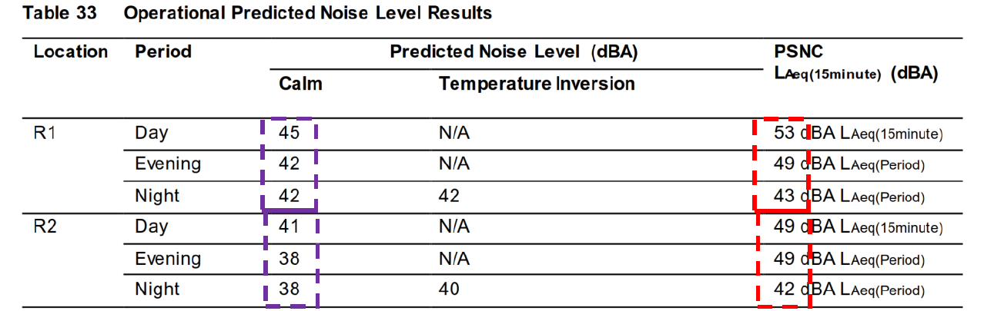
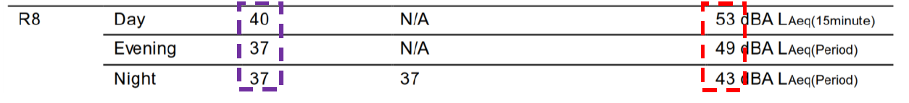
Figure 17 – Applicants extract from SLR report submitted and approved under parent Application (DA2015/177)

The Applicant has also provided a useful image of where these receivers are located in the context of the site.
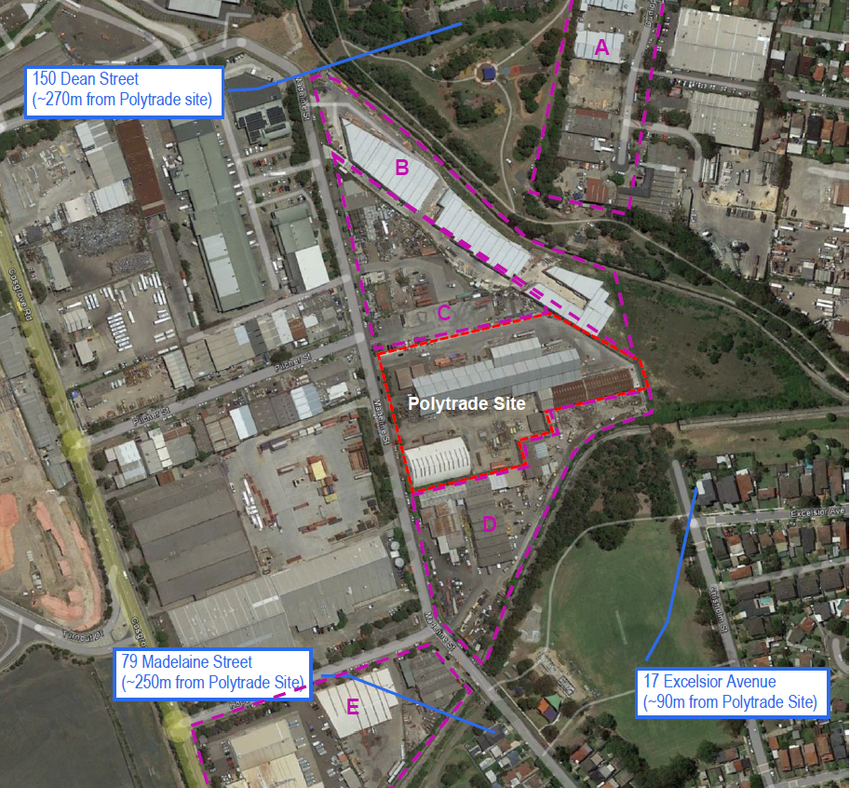
Figure 18 – Applicants image in Wave Consulting report showing receivers relevant to Condition 76

Condition 9 requires auditing to be undertaken in accordance with the SLR criteria (PSNC) established in the approved acoustic assessments and does not directly reference the noise limits established by the EPA. This reflects some inconsistencies in the conditions applied with regard to acoustic attenuation and monitoring of the approved use.

The Applicant has proposed that it is the PSNC that should also be applied to Condition 76, rather than the EPA’s noise limits.

However, the EPA have provided direct advice to Council that the noise limits established in Condition 76 have been based on the NSW Industrial Noise Policy and Council agrees with the NSW EPA statements on the following:

- The Applicant has outlined the modifications are minor and will not increase noise generation. Considering this, there should be no need to adjust the noise limits established in Condition 76.
- If the Applicant believes the modifications would result in increased noise generation, an amended acoustic assessment would be required to establish new attenuation measures for the predicted increases in noise.

Accordingly, Council is not in a position to amend Condition 76 to adopt the PSNC provided by SLR, when the EPA has been clear in their advice regarding the noise limits applied in their original GTA’s.

Council is also unable to support the changes to MRF and PCF locations without an acoustic report that addresses the potential additional acoustic attenuation measures and provides a new program for auditing /verification following the amended layout. Based on the EPA’s advice, these new acoustic attenuation measures would also need to bring the operation into compliance with the existing noise limits set out under Condition 76.

Waste Management Impacts

As outlined above under the assessment against Part H of SCDCP 2005, the Applicant has not provided sufficient information to justify the changes to Condition 38 which prohibits the external storage of baled and sorted waste.

It is also noted that during Council’s site inspection, a number of uncovered external structures are currently being used for storage of baled and sorted waste (refer to Figure 14). On the approved site layout, these storage areas are identified as being rooved which presents additional non-compliance matters relating to Condition 38 and may further undermine the management of waste at the site.

It is understood that condition 38 was imposed to reduce the potential for loose materials leaving the premises and no supplementary mitigation measures have been submitted by the Applicant to justify removal of the condition.

(c) the suitability of the site for the development,

It is considered that the proposed development, as modified, is of a scale and design that is suitable for the site having regard to its size and shape, its topography and vegetation.

However, insufficient information has been provided in relation to acoustic impacts and attenuation measures to support the proposed amendments to the site layout and amendments to Condition 76 to change the noise limits for the site. Accordingly, it is unclear whether the proposed modification is suitable for the site in the context of surrounding residential development.

(d) any submissions made in accordance with this Act or the regulations,

In accordance with the provisions of Councils Community Participation Plan, the application was placed on neighbour notification for a period of fourteen (14) days where adjoining property owners were notified in writing of the proposal and invited to comment. Three (3) submissions were received raising the following concerns:

1. The site is currently emitting uncomfortable noise emissions at early hours of the morning and during public holidays and the proposed Application will worsen the existing situation.

Comment: The submission is primarily a compliance matter and Council’s Compliance and Regulatory Manager has advised the site has a history of breaching hours of operation, causing offensive noise to the surrounding residents and is subject to ongoing noise complaints from surrounding residents.

Noting the submission comment regarding the worsening of the existing situation due to the proposed modifications, it is noted in this assessment that Council does not have sufficient information to address this matter. Further, the Noise Audit provided by the Applicant demonstrates non-compliance with the noise limits under Condition 76.

2. The site has not undertaken operation in accordance with the consent and the use of MRF in the rear shed will worsen the noise impacts. 24 hour operation should not be permitted and paper and cardboard storage should be distanced to reduce fire hazard.

Comment: Refer above comments regarding compliance matters and the lack of information to determine the impacts associated with re-location of MRF to Building 2 and/or the merit in amending the noise limits established under Condition 76.

The existing consent and EPL license addresses fire hazard management.

3. The site has breached the conditions of consent imposed by the JRPP, with roller doors open day and night (Condition 5). Because of the longer hours of operations and the noisier nature of the processing it is unacceptable that the MRF be allowed to relocate to building 2 as this is significantly closer to residents, being only approximately 50m from the closest homes. There is nothing to prevent this noise travelling to the closest homes and beyond. The noise heard from Polytrade when Aussie Skips is not operating with the existing building usage is already unacceptable, but to allow this noise and a 4.30 am start with the dumping of garbage trucks full of heavy recyclable waste, is unacceptable.

Comment: The objection outlines that roller doors are not permitted to be open during day time hours, which is generally reflected in the below condition:

Condition 37 - All operations/activities shall be carried out wholly within the building. The roller doors shall remain closed at all times when delivery and dispatch is not occurring.

The Applicant’s concerns regarding roller doors being left open have some merit and Council’s manager of Compliance and Regulatory Services has outlined this matter has been raised with the owner, however more generally in relation to the closing of roller doors during cleaning periods (10pm to 5am).

In the context of the proposed modification, the above compliance concerns are relevant to the Applicant’s proposal to modify the noise limits set by the EPA and modify the overall layout without proposed mitigation measures within an acoustic report. The above concern reinforces the assessment conclusions outlined elsewhere in this report.

(e) the public interest.

The Application is not in the public interest as the proposed modification is not supported by adequate investigation into the potentially offensive noise emissions.

Local Infrastructure Contributions

Section 7.13 of the EP&A Act 1979 relates to the collection of monetary contributions from applicants for use in developing key local infrastructure. This section prescribes in part as follows:

A consent authority may impose a condition under section 7.11 or 7.12 only if it is of a kind allowed by, and is determined in accordance with, a contributions plan (subject to any direction of the Minister under this Division).

STRATHFIELD INDIRECT SECTION 7.12 CONTRIBUTIONS PLAN

Section 7.12 Contributions are applicable to the proposed development however a fee has not been calculated as the recommendation is for refusal.

Conclusion/Recommendation

The application for modification has been assessed having regard to the Heads of Consideration under Section 4.15 (1) of the Environmental Planning and Assessment Act 1979, the provisions of the SLEP 2012 and SCDCP 2005.

The application incorporates a number of proposed amendments, however the Application as a whole is recommended for refusal due to the interconnectedness of each proposed amendment to the central issue of noise emissions and mitigation.

Pursuant to Section 4.55(2) of the Environmental Planning & Assessment Act 1979 and following detailed assessment of the proposed modifications to Development Consent No. 177/2015 for alterations and additions to an approved materials recycling facility, be refused for the reasons outlined in the attached reasons for refusal.

Signed: Date: 05/08/2022
J Gillies
Senior Planner

I confirm that I have determined the abovementioned development application with the delegations assigned to my position;

I have reviewed the details of this development application and I also certify that Section 7.11/7.12 Contributions are applicable to this development and have been levied accordingly;

Report and recommendations have been peer reviewed and concurred with.

Signed: Date: 05/08/2022
Gary Choice
Planner

Under Section 4.16(1)(b) of the Environmental Planning and Assessment (EP&A Act, 1979, this consent is REFUSED for the following reason;

(1) Refusal Reason – Environmental Planning Instrument
Pursuant to Section 4.15 (1)(a)(i) of the Environmental Planning and Assessment Act 1979, the proposed development does not comply with the relevant environmental planning instruments in terms of the following:
- The proposal fails to satisfy section 3.12 of Part 3 of State Environmental Planning Policy (Resilience and Hazards) in that the EPA has advised in consultation that the noise limits should not be modified and that there is insufficient information to determine the suitability of the proposed site layout changes in terms of noise impacts on surrounding residential receivers.

(2) Refusal Reason - Development Control Plan
Pursuant to Section 4.15 (1)(a)(iii) of the Environmental Planning and Assessment Act 1979, the proposed development does not comply with the following sections of the Strathfield Consolidated Development Control Plan 2005 in terms of the following:
- The proposed development is considered unacceptable as it fails to meet the objectives and guidelines of Clause 2.4 under Part D of the Strathfield Consolidated Development Control Plan 2005. The proposal will result in a reduction in noise limits and changes to the site layout that are not supported by adequate acoustic investigation and mitigation measures and may worsen the noise nuisance for nearby residents.

- The proposed development is considered unacceptable as it fails to meet the guidelines of Clause 2.14.2 under Part D of the Strathfield Consolidated Development Control Plan 2005. The proposal will result in a reduction in noise limits and changes to the site layout that are not supported by adequate acoustic investigation and mitigation measures.

- The proposed development is considered unacceptable as it fails to meet the objectives and guidelines under Part H of the Strathfield Consolidated Development Control Plan 2005. The proposal seeks to delete Condition 38 which would be inconsistent with the following controls under Part H:
- 1.6(c)
- 3.9.3(a)
- 3.9.3(c)

(3) Refusal Reason – Impacts on the Environment
Pursuant to Section 4.15 (1)(b) of the Environmental Planning and Assessment Act 1979, the proposed development is likely to have an adverse impact on the following aspects of the environment:
- Built and social environment – The Proposal seeks to amend the noise limits and re-organise the site layout and inadequate information has been provided to demonstrate this will not harm the amenity of surrounding residential areas.
- Natural environment – The Proposal seeks to remove a condition (38) which is in place to reduce general waste leaving the site and littering the surrounding environment.

(4) Refusal Reason – Suitability of Site
Pursuant to Section 4.15 (1)(c) of the Environmental Planning and Assessment Act 1979, the site is not considered suitable for the proposed development for the following reasons:
- Inadequate information has been supported in relation to acoustic impacts and attenuation measures to support the proposed amendments to the site layout and amendments to Condition 76 to change the noise limits for the site. Accordingly, it is unclear whether the proposed modification is suitable for the site in the context of surrounding residential development.

(5) Refusal Reason – Public Interest
Pursuant to Section 4.15 (1)(e) of the Environmental Planning and Assessment Act 1979, the proposed development is not considered to be in the public interest as the proposed modification is not supported by adequate investigation into the potentially offensive noise emissions.

